QUESTION 4

* *Hard* - For our hard activation function the overall average accuracy between training percentages rounded to 94.8%. This average is composed of the accuracies found from the training percentages 75%, 50%, and 25%. At 75% the average equaled 95.2%. At 50% the average equaled 94%. Finally, at 25% the average equaled 95.1%. This seems to be a fairly awkward trend with a fairly counterintuitive idea that a neuron that has been trained less can actually outperform one that was trained twice as much. We believe this occurs because our random data is stored in a fashion that has a higher proportion of one sex between the first 25% of people and the second 25%. The small overall difference however stems from what we believe to be that the point of convergence has already occurred before the 25% mark and any data read in after this value will make an adjustment to the weights that would simply teeter-totter around the most accurate solution.
* *Soft* - For our soft activation function the overall average accuracy between training percentages rounded to 94.5%. This average is composed of the accuracies found from the training percentages 75%, 50%, and 25%. At 75% the average equaled 94.9%. At 50% the average equaled 94.3%. Finally, at 25% the average equaled 94.4%. This seems to be a fairly awkward trend with a fairly counterintuitive idea that a neuron that has been trained less can actually outperform one that was trained twice as much. We believe this occurs because our random data is stored in a fashion that has a higher proportion of one sex between the first 25% of people and the second 25%. The small overall difference however stems from what we believe to be that the point of convergence has already occurred before the 25% mark and any data read in after this value will make an adjustment to the weights that would simply teeter-totter around the most accurate solution.

Extra Credit / PLOTS

* *75% Training Data* - Overall the difference of accuracy from the hard and soft functions of a 25% dataset is very miniscule. The average accuracy of the hard function was about 95%, whereas the accuracy of the soft function was 95.1%. Having a difference in accuracy this small lead to a very small difference in the change of weights as well. Therefore the separation lines had a difference of .002 for the slope and .005 for the intercept.
* *50% Training Data* - Similar to the 25% training data, the 50% training did not differ much between the hard and soft functions. The average accuracy of the hard function was 94.4% and the accuracy for the soft function was 94%. The difference in error is larger than the .1% of the 75% training data but it is still less than .5% difference. Thus the separation lines for this training data did not differ much as well.
* *25% Training Data* - Unlike the other two the difference between the accuracies of the hard and soft functions changed the values of the line enough to actually make a difference in the slope and the intercept. The intercept value for the hard function was .846 whereas the soft function was .791. This made the two lines extremely noticeable when plotting the separation line. The soft function seems to produce better results when there is less data being trained

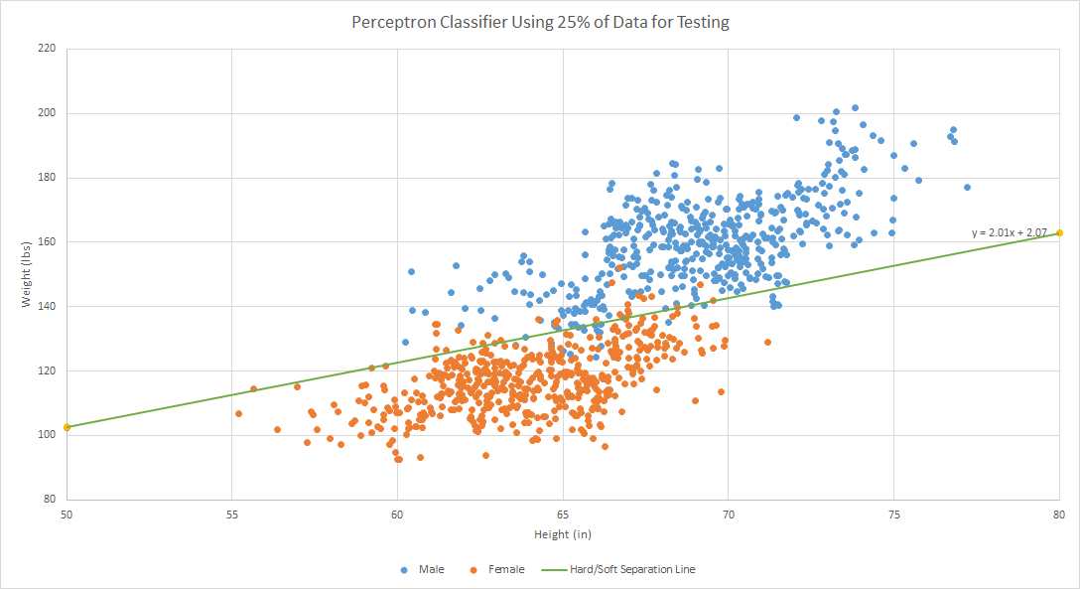

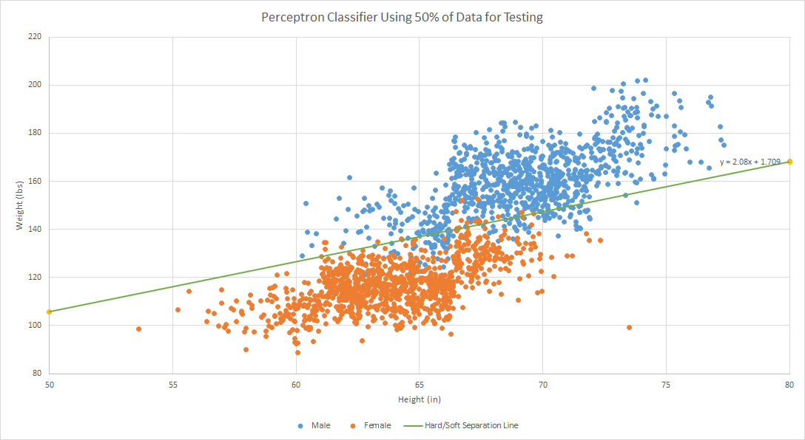

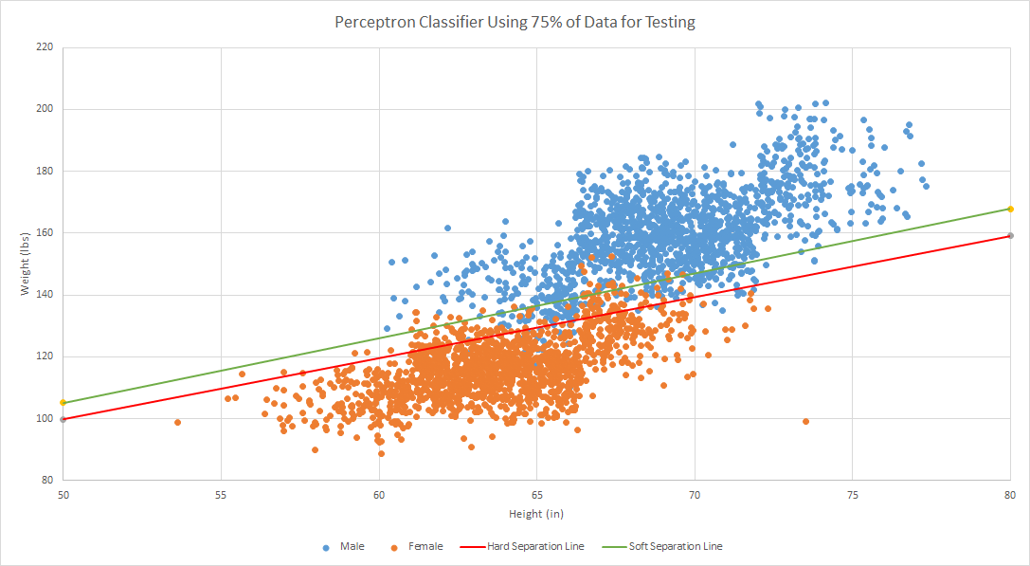

Workload Distribution:

*Andrew Bailey:* Worked on coding the hard and soft activation functions, as well as plotted the separation lines in excel

*Aditya Vadrevu:* Worked on the extra credit portion of the report

*Jordan Mays-Rowland:* Worked on question 4 of the report